The Best Eid Ever

- Brainstorm W questions with class – on board. Practice saying them. “Who is there? What are they doing? Why are they doing this? When is it? Where is it?” Students stand in a line: One facing board with cover without title, the other not. The one NOT facing asks questions. The OTHER answers. Swap and do this again.
- We are going to read the story “The best Eid ever”. What do you know about EID? KWL on board : Eid al-Adha 2015 begins in the evening of September 22 and ends in the evening of September 23
- Now do the information gap – read it quietly and figure it out. Then read in pairs and find the missing words. Give pictures a caption and decide what the picture shows, which aspect of the text?
- Preteach following words: Prayer, pilgrimage, …and ones from cards/strips/board (I am more and more convinced that we should have kids copy, not prepare for them).
- Read the story, as I go ask questions and simplify the text. One child on a rotating basis acts as Aneesa.
- Fill in KWL chart more – what more do you know now?
- Copy story the class and scan in. Re-read the story in pairs – ask them what adaptations they would make to the reading in a 2nd or a 6th grade. Tell it together and talk about the telling of it – how to make it interactive…
- Brainstorm potential for follow up activities in ELT – language level or content level. Language level – put strips in order / play charades with them or each quietly fills in a Who-What-Where-Why-When-How sheet.
- Content level, do food activity or relate to Kwanzaa activity.

Aneesa’s parents are away in Saudi Arabia. Show ‘Saudi Arabia’.
Aneesa is sad. Show ‘sad’.
Aneesa is from Pakistan. Show ‘Pakistan’.
Aneesa lives in the United States. Show ‘the United States’.
Aneesa’s grandmother is babysitting. Show ‘babysitting’.
Aneese puts on her new clothes. Show ‘put on clothing’.
Aneesa likes lamb korma. Show ‘eat’!
Aneesa meets two girls. Show her meeting two girls.
The two girls are new to the United States. Show ‘new’.
The two new girls are poor. Show ‘poor’.
Aneesa shares her food and clothing with the two new girls. Show Aneesa ‘sharing her food and clothes’.
The two new girls share the food and clothing with their neighbors. Show ‘share with neighbors’.
Aneesa and her grandmother hide in the bushes. Show ‘hiding’.
Aneesa and her grandmother eat pizza for dinner. Show ‘eating pizza’.
It was a happy day. Show ‘happy day’!

Eid al-Adha
Source: http://simple.wikipedia.org/wiki/Eid_al-Adha
Eid al-Adha (Arabic: عيد الأضحى ‘Īdu l-’Aḍḥā) "Festival of Sacrifice" or "Greater Bairam" is a religious festival celebrated by Muslims all over the world. It is when Muslims sacrifice (opfern) a goat, sheep, cow or a camel, and share it with poor people. It marks the end of the Pilgrimage (Pilgerfahrt: religious voyage) or Hajj for the millions of Muslims who make the trip to Mecca each year and pray many times a day.
The festival is to celebrate Ibrahim's (Abraham’s) willingness (Bereitschaft) to sacrifice his son, Ishmael, because Allah told him to do so in a dream. At the final moment, God said “No! Not your son - a lamb”. This act is copied by Muslims all over the world today on Eid.
Muslims celebrate by having a feast, and giving gifts to the poor. In some Muslim traditions, gifts are also given to children. In Muslim countries the day is a national holiday.

.

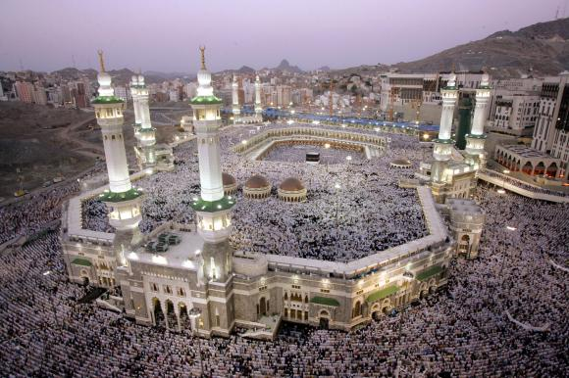
A.
Eid al-Adha
Source: http://simple.wikipedia.org/wiki/Eid_al-Adha
Eid al-Adha (Arabic: عيد الأضحى ‘Īdu l-’Aḍḥā) "Festival of Sacrifice" or "Greater Bairam" is a religious ___________ celebrated by Muslims all over the world. It is when Muslims sacrifice (opfern) a goat, sheep, ___________ or a camel, and share it with poor people. It marks the ___________ of the Pilgrimage (Pilgerfahrt: religious voyage) or Hajj for the millions of Muslims who make the ___________ to Mecca each year and pray many times a day.
The festival is to ___________ Ibrahim's (Abraham’s) willingness (Bereitschaft) to sacrifice his son, Ishmael, because Allah told him to do so in a ___________. At the final moment, God said “No! Not your son - a ___________”. This act is copied by Muslims all over the world today on Eid.
Muslims celebrate by having a ___________, and giving gifts to the poor. In some Muslim _________, gifts are also given to children. In Muslim countries the day is a national holiday.

B.
Eid al-Adha
Source: http://simple.wikipedia.org/wiki/Eid_al-Adha
Eid al-Adha (Arabic: عيد الأضحى ‘Īdu l-’Aḍḥā) "___________ of Sacrifice" or "Greater Bairam" is a religious festival celebrated by Muslims all over the world. It is when Muslims sacrifice (opfern) a ___________, sheep, cow or a camel, and share it with ___________ people. It marks the end of the Pilgrimage (Pilgerfahrt: religious voyage) or Hajj for the ___________ of Muslims who make the trip to Mecca each year and pray many times a ________.
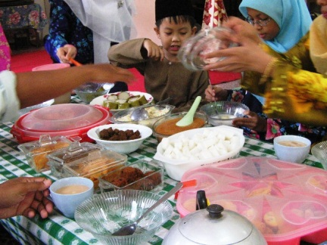
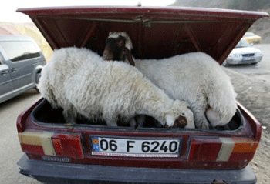
The festival is to celebrate Ibrahim's (Abraham’s) willingness (Bereitschaft) to sacrifice his son, Ishmael, ___________ Allah told him to do so in a dream. At the ___________ moment, God said “No! Not your son - a lamb”. This act is copied by Muslims all over the ___________ today on Eid.
Muslims celebrate by having a feast, and giving ___________ to the poor. In some Muslim traditions, gifts are also given to ___________. In Muslim countries the day is a national holiday.

Recipe charades

- Read through these instructions.
- Read through your recipe.
- Plan a skit with your recipe – every member of your group must participate, you must act out chefs, food items and cooking utensils.
- Practice your skit.
- Act it out to the class once – they will guess what the recipe is.
- Choose 2 classmates. They will be the “recipe announcers” as you act it out a 2nd time. They will narrate your recipe step by step. The other classmates will write down / list the steps.

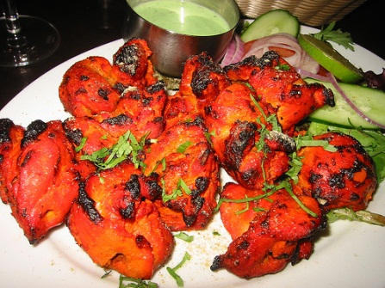
Tandoori Chicken
Ingredients:
1 chicken cut into pieces
3 small black cloves
5 red dried chilies
1/2 pint of natural yogurt
2 cloves ground crushed garlic
11/2 teaspoons chili powder
1/8 cup of butter
2 teaspoons salt
1/2 teaspoon powdered red food coloring
1 teaspoon ground ginger

Method:
- Grind the cloves and dried chilies and set aside.
- Mix the yogurt, salt, food coloring, ground ginger, garlic, and chili powder and the ground ingredients.
- Place the chicken pieces in a dish and pour the yogurt over them.
- Leave to marinate.
- Smear a large piece of foil with butter.
- Arrange the chicken on the foil with the marinated mixture and dot the butter on top.
- Fold the foil around the chicken and seal and bake for about 45 minutes or until done.
Serve immediately with lemon wedges and green chilies.

Recipe charades

- Read through these instructions.
- Read through your recipe.
- Plan a skit with your recipe – every member of your group must participate, you must act out chefs, food items and cooking utensils.
- Practice your skit.
- Act it out to the class once – they will guess what the recipe is.
- Choose 2 classmates. They will be the “recipe announcers” as you act it out a 2nd time. They will narrate your recipe step by step. The other classmates will write down / list the steps.

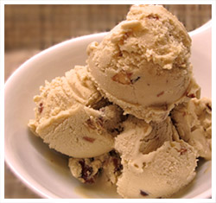
Ingredients:
1 lb of blanched almonds
1 pint of heavy cream
4 tablespoons rose essence.
6 pints of whole milk
1 lb sugar
Method:
Place the almonds in a large bowl.
- Cover them with cold water and set aside.
- Set aside 1/2 pint of the milk.
- Boil the rest of the milk in a large non stick saucepan.
- Simmer until the milk is reduced by half. Stir from time to time.
- Drain the almonds.
- Grind them. Mix them with the 1/2 pint of milk.
- Add almond mixture and sugar to the hot milk and continue stirring on low heat for 20-30 minutes.
- Cool to room temperature.
- Place in the refrigerator until well chilled.
- Chop the remaining almonds, but not too finely and stir into the chilled milk mixture.
- Add the heavy cream and the rose essence.
- Stir to mix all the ingredients.
- Pour into a freezer safe container and freeze until solid.

Recipe charades

- Read through these instructions.
- Read through your recipe.
- Plan a skit with your recipe – every member of your group must participate, you must act out chefs, food items and cooking utensils.
- Practice your skit.
- Act it out to the class once – they will guess what the recipe is.
- Choose 2 classmates. They will be the “recipe announcers” as you act it out a 2nd time. They will narrate your recipe step by step. The other classmates will write down / list the steps.

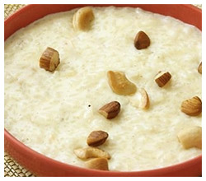
Kheer - Rice Pudding
Ingredients:
1 cup of cooked basmati rice (long grain rice)
8 green cardamom pods crushed
2 tablespoons rose essence
- tablespoons ground pistachio nuts
71/2 cups of whole milk
12 tablespoons sugar

Method:
- Finely grind the rice and place it in a saucepan with the cardamoms.
- Add 6 3/4 cups of milk and boil over medium heat stirring continuously.
- Add remaining milk and cook over a medium heat until the rice mixture thickens to a creamy consistency. Add sugar and the rose water.
- Continue to cook for another 2 minutes.
- Serve chilled, and garnished with nuts.

Recipe charades

- Read through these instructions.
- Read through your recipe.
- Plan a skit with your recipe – every member of your group must participate, you must act out chefs, food items and cooking utensils.
- Practice your skit.
- Act it out to the class once – they will guess what the recipe is.
- Choose 2 classmates. They will be the “recipe announcers” as you act it out a 2nd time. They will narrate your recipe step by step. The other classmates will write down / list the steps.
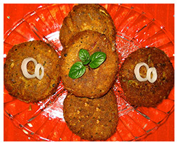
Shami Kebab
Ingredients
½ kg minced meat (hamburger) without fat
2 tbsp chana dal (split gram) washed and soaked in water for ½ hr
2 pieces dalchini. (cinnamon)
- cloves
1 piece ginger
1 tsp coriander and cumin powder
1 tsp garam masala.(mixed spices)
10 garlic flakes
2 elaichi. (cardamom)
1 tsp chili powder
A pinch of pepper
A handful of Kothmir and chopped pudina.(mint leaves)
1 egg
Juice of ½ a lemon
1 finely chopped onion
Salt
Method
- Wash and drain the mince.
- Mix the split gram, whole spices, a cup of water and salt to taste. Cook until it becomes dry.
- Remove from the fire and add ginger, garlic, pepper, chili powder, coriander and cumin powder and grind the mixture into a fine paste and knead into a dough.
- Add the chopped mint leaves, kothmir, lime juice and salt to taste.
- Make lemon sized balls of the dough, flatten the balls and stuff them with a little onion mixture.
- Dip the stuffed kebabs in the beaten eggs and shallow fry until cooked.

Recipe charades

- Read through these instructions.
- Read through your recipe.
- Plan a skit with your recipe – every member of your group must participate, you must act out chefs, food items and cooking utensils.
- Practice your skit.
- Act it out to the class once – they will guess what the recipe is.
- Choose 2 classmates. They will be the “recipe announcers” as you act it out a 2nd time. They will narrate your recipe step by step. The other classmates will write down / list the steps.

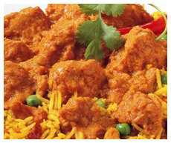
Korma
Ingredients:
3 tablespoons of Corn oil
1 chicken cut into pieces
1 teaspoon garam masala
1/2 teaspoon chili powder
2 green chilies
3 large tomatoes
2 large red onions
2 teaspoons ginger paste
2 teaspoons garlic paste
5 black peppercorns
2 black cardamom pods
2 teaspoons salt
2 tablespoons half and half
2 tablespoons natural yogurt
1 teaspoon lemon juice.
Method:
Heat the oil in a large heavy bottomed pan.
Sauté the finely sliced onions until the color changes to golden brown.
Add the ginger, garlic, chili, mixed spices, salt, cardamom, and peppercorns and mix well.
Chop the tomatoes, and add them to the mixture. Stir well for two to three minutes.
Add the chicken and fry on high heat and coat the chicken mixture with the spices.
Reduce heat to low and cover. Let the chicken cook for 25 minutes.
Add yogurt, lemon juice and chilies.
Let cook on low heat for another 20 minutes. Serve.

